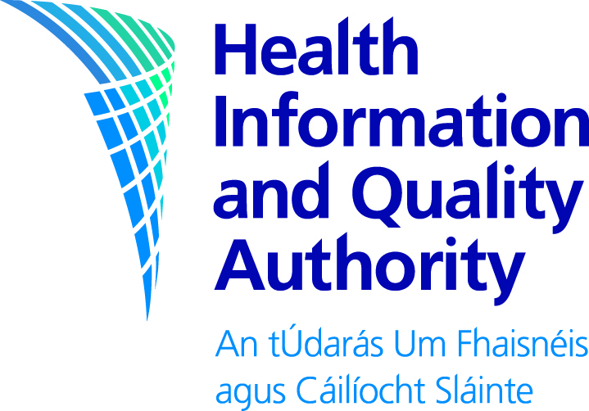

Draft Guidelines for the Budget Impact Analysis of Health Technologies in Ireland

For public consultation

Consultation Feedback Form

October 2017

Your feedback is very important to us. We welcome responses to all questions as well as any additional comments you would like to make.

When commenting on a specific section of a document, it would help if you can identify which element you are commenting on and the relevant page number.

The closing date for consultation is 5pm on Wednesday 15 November 2017

You may email or post a completed form to us. You may also complete and submit your feedback online at www.hiqa.ie.

About you

Name

Address
Contact details

Date

General Information and Questions

You may provide us with feedback on the specific questions (see questions that follow), or alternatively you may provide us with general comments.

Part 1

Are you replying in a personal capacity or on behalf of an institution or organisation?

Personal capacity
On behalf of an institution
On behalf of an organisation

Part 2

Please outline any general or specific feedback on the documents. In your response, where applicable, please specify the section or page and line number to which you are referring.

Please comment

Thank you for taking the time to give us your views.

After the closing date, we will assess all feedback and use it to finalise our documents. The final documents and the Statement of Outcomes (a summary of the responses) will be published on http://www.hiqa.ie.
If you wish to do so, you can request that your name and/or organisation be kept confidential and excluded from the published summary of responses. Please note that we may use your details to contact you about your responses. We do not intend to send responses to each individual respondent.

Please return your form to us either by email or post:

consultation@hiqa.ie

Health Information and Quality Authority
HTA on Public Access Defibrillation
George’s Court
George’s Lane
Dublin 7

If you have any questions you can contact the consultation team
by calling (01) 814 7463.

Please return your form to us either by email or post before

5pm on Wednesday 15 November 2017

Please note that the Authority is subject to the Freedom of Information Acts and the statutory Code of Practice regarding FOI.

For that reason, it would be helpful if you could explain to us if you regard the information you have provided as confidential. If we receive a request for disclosure of the information we will take full account of your explanation, but we cannot give an assurance that confidentiality can be maintained in all circumstances.

