Restrictive Practice Thematic Programme
Quality Improvement Plan

Designated Centres for People with Disabilities

Introduction
The aim of thematic inspections is to help drive quality improvements in specific aspects of care and support. These thematic programmes will focus primarily on the National Standards for Residential Services for Children and Adults with Disabilities (2013). This Quality Improvement Plan is specifically designed for use in the thematic inspections of restrictive practices in designated centres for people with disabilities.
This document can be used in conjunction with the self-assessment questionnaire for restrictive practices. Alternatively you may choose to use you own template. Once your service has completed the self-assessment questionnaire, this plan provides an opportunity for the service to target areas for improvement under each of the eight themes. This quality improvement plan is not required to be submitted to the Office of the Chief Inspector. It should be used by the centre to focus on what improvements are needed and how they will be progressed and monitored. The quality improvement plan should be made available to an inspector upon request as it will demonstrate initiatives being undertaken in relation to reducing and eliminating the use of restrictive practices in the centre.
Service providers are encouraged to read the guidance document accompanying this thematic programme as it will provide useful information on meeting the standards.
*Please Note: This quality improvement plan is a template produced by the Office of the Chief Inspector. You are not required to use this template and are free to use an alternate tool or template to create a quality improvement plan. However, please ensure that your plan incorporates the main elements as set out in this template.

Figure 1: Themes in the National Standards for Residential Services for Children and Adults with Disabilities (2013)
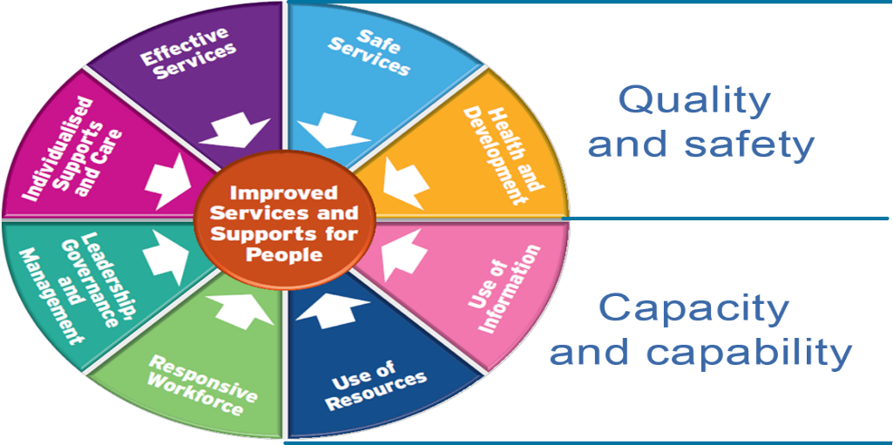

Section 1 - Capacity and capability
This section focuses on the overall delivery of the service and how the provider is assured that an effective and safe service is provided. Delivering improvement depends on services having capability and capacity in four key areas.
This includes how the provider:
- makes sure there are effective governance structures with clear lines of accountability so that all members of the workforce are aware of their responsibilities and to whom they are accountable
- ensures that the necessary resources are in place to support the effective delivery of quality care and support to people using the service
- designs and implements policies and procedures to enable centres run effectively
- uses information as a resource for planning, delivering, monitoring, managing and improving care.

Section 2 - Quality and safety
The focus of this section is about the lived experience of the people using the service.
This includes how people:
- make choices and are actively involved in shaping the services they receive
- are empowered to exercise their rights, achieve their personal goals, hopes, and aspirations
- receive effective person-centred care and support, at all stages of their lives
- are able to live in a safe, comfortable and homely environment
- have food and drink that is nutritious
- are protected from any harm or abuse.

Quality Improvement Plan
Section 1 – Capacity and Capability
Dimension: Capacity and capability
Theme: Leadership, Governance and Management
Please outline your key achievements relevant to restrictive practices under the Leadership, Governance and Management theme within the last year

Outline where there is room for improvement under the Leadership, Governance and Management theme
Standard number  *5.___ | Standards assessed as requiring a Quality Improvement Initiative  *Please place the standard number requiring a Quality Improvement initiative into the box on the left  Copy and paste this box if you require additional plans for each standard
Area(s) identified as requiring improvement

Priority level
High/Medium/Low

Actions to be taken
Person responsible
Resources needed
Possible constraints
Measures of success
Timeframe
Progress review date(s)
Standard number  *5.___ | Standards assessed as requiring a Quality Improvement Initiative  *Please place the standard number requiring a Quality Improvement initiative into the box on the left  Copy and paste this box if you require additional plans for each standard
Area(s) identified as requiring improvement

Priority level
High/Medium/Low

Actions to be taken
Person responsible
Resources needed
Possible constraints
Measures of success
Timeframe
Progress review date(s)
Dimension: Capacity and Capability
Theme: Use of Resources
Please outline your key achievements relevant to restrictive practices under the Use of Resources theme within the last year
Outline where there is room for improvement under the Use of Resources theme
Standard number  6.1 | Standard assessed as requiring a Quality Improvement Initiative  Yes No
Area(s) identified as requiring improvement

Priority level
High/Medium/Low

Actions to be taken
Person responsible
Resources needed
Possible constraints
Measures of success
Timeframe
Progress review date(s)

Dimension: Capacity and capability
Theme: Responsive Workforce
Please outline your key achievements relevant to restrictive practices under the Responsive Workforce theme within the last year
Outline where there is room for improvement under the Responsive Workforce theme
Standard number  *7.___ | Standards assessed as requiring a Quality Improvement Initiative  *Please place the standard number requiring a Quality Improvement initiative into the box on the left  Copy and paste this box if you require additional plans for each standard
Area(s) identified as requiring improvement

Priority level
High/Medium/Low

Actions to be taken
Person responsible
Resources needed
Possible constraints
Measures of success
Timeframe
Progress review date(s)
Dimension: Capacity and Capability
Theme: Use of Information
Please outline your key achievements relevant to restrictive practices under the Use of Information theme within the last year
Outline where there is room for improvement under the Use of Information theme

Standard number  8. ___ | Standard assessed as requiring a Quality Improvement Initiative  *Please place the standard number requiring a Quality Improvement initiative into the box on the left  Copy and paste this box if you require additional plans for each standard
Area(s) identified as requiring improvement

Priority level
High/Medium/Low

Actions to be taken
Person responsible
Resources needed
Possible constraints
Measures of success
Timeframe
Progress review date(s)
Section 2 - Quality and Safety
Dimension: Quality and Safety
Theme: Person-centred Care and Support
Please outline your key achievements relevant to restrictive practices under the Person–centred Care and Support theme within the last year
Outline where there is room for improvement under the Person–centred Care and Support theme

 | Standard number  *1.___ |  | Standards assessed as requiring a Quality Improvement Initiative  *Please place the standard number requiring a Quality Improvement initiative into the box on the left  Copy and paste this box if you require additional plans for each standard
 | Area(s) identified as requiring improvement
Priority level
High/Medium/Low

 | Actions to be taken
 | Person responsible
 | Resources needed
 | Possible constraints
 | Measures of success
 | Timeframe
 | Progress review date(s)
Dimension: Quality and Safety
Theme: Effective Services
Please outline your key achievements relevant to restrictive practices under the Effective Services theme within the last year
 | Outline where there is room for improvement under the Effective Services theme
 | Standard number  *2.___ |  | Standard assessed as requiring a Quality Improvement Initiative  *Please place the standard number requiring a Quality Improvement initiative into the box on the left  Copy and paste this box if you require additional plans for each standard
 | Area(s) identified as requiring improvement
Priority level
High/Medium/Low

 | Actions to be taken
 | Person responsible
 | Resources needed
 | Possible constraints
 | Measures of success
 | Timeframe
 | Progress review date(s)
Standard number  *2. ___ |  | Standard assessed as requiring a Quality Improvement Initiative  *Please place the standard number requiring a Quality Improvement initiative into the box on the left  Copy and paste this box if you require additional plans for each standard
Area(s) identified as requiring improvement

Priority level
High/Medium/Low

Actions to be taken
Person responsible
Resources needed
Possible constraints
Measures of success
Timeframe
Progress review date(s)
Dimension: Quality and Safety
Theme: Safe Services
Please outline your key achievements relevant to restrictive practices under the Safe Services theme within the last year
Outline where there is room for improvement under the Safe Services theme
 | Standard number  *3.___ |  | Standards assessed as requiring a Quality Improvement Initiative  *Please place the standard number requiring a Quality Improvement initiative into the box on the left  Copy and paste this box if you require additional plans for each standard
 | Area(s) identified as requiring improvement
Priority level
High/Medium/Low

 | Actions to be taken
 | Person responsible
 | Resources needed
 | Possible constraints
 | Measures of success
 | Timeframe
 | Progress review date(s)
Standard number  *3.___ |  | Standards assessed as requiring a Quality Improvement Initiative  *Please place the standard number requiring a Quality Improvement initiative into the box on the left  Copy and paste this box if you require additional plans for each standard
Area(s) identified as requiring improvement

Priority level
High/Medium/Low

Actions to be taken
Person responsible
Resources needed
Possible constraints
Measures of success
Timeframe
Progress review date(s)
Dimension: Quality and Safety
Theme: Health and Wellbeing
Please outline your key achievements relevant to restrictive practices under the Health and Wellbeing theme within the last year
 | Outline where there is room for improvement under the Health and Wellbeing theme
 | Standard number  *4. ___ |  | Standard assessed as requiring a Quality Improvement Initiative  *Please place the standard number requiring a Quality Improvement initiative into the box on the left  Copy and paste this box if you require additional plans for each standard
 | Area(s) identified as requiring improvement
Priority level
High/Medium/Low

 | Actions to be taken
 | Person responsible
 | Resources needed
 | Possible constraints
 | Measures of success
 | Timeframe
 | Progress review date(s)

To be completed at the end of the Quality Improvement Plan cycle
Standards assessed as requiring improvement | Measures of success | Status  (completed  /in progress) | Progress notes

