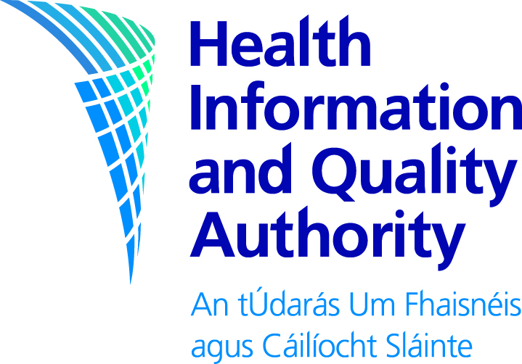

Health Technology Assessment of the addition of Herpes Zoster (shingles) vaccination to the adult immunisation schedule

For public consultation

Consultation Feedback Form

Your feedback is very important to us. We welcome comments you would like to make.

When commenting on a specific section of a document, it would help if you can identify which element you are commenting on and the relevant page number.

The consultation remains open until 5pm on 30 April 2024

You may email a completed form to us at consultation@hiqa.ie . You may also complete and submit your feedback online at https://hiqa.survey.fm/public-consultation-expanding-childhood-immunisation-schedule-to-include-chickenpox-vaccine

About you

Name

You or your organisation’s country
Today’s Date

General Information and Questions

You may provide us with feedback on the specific questions (see questions that follow), or alternatively you may provide us with general comments.

Part 1

Are you replying in a personal capacity or on behalf of an institution or organisation?

☐ Personal capacity
☐ On behalf of an institution | Please name
☐ On behalf of an organisation | Please name

Part 2

Please provide any general or specific feedback you have on the draft assessment. Where applicable, please specify the section of the assessment to which you are referring.

Please comment

Part 3

Please outline any issues with the clarity or presentation of the report. In your response, where applicable, please specify the section to which you are referring.

Please comment

Thank you for taking the time to give us your views.

After the closing date, we will assess all feedback and use it to finalise our documents. The final documents and the Statement of Outcomes (a summary of the responses) will be published on http://www.hiqa.ie.
If you wish to do so, you can request that your name and/or organisation be kept confidential and excluded from the published summary of responses. Please note that we may use your details to contact you about your responses. We do not intend to send responses to each individual respondent.

Please return your form to us either by email:

consultation@hiqa.ie

or complete it online at: https://hiqa.survey.fm/public-consultation-expanding-childhood-immunisation-schedule-to-include-chickenpox-vaccine

Postal address:
Shingles Vaccine Public Consultation
HIQA
Communications and Stakeholder Engagement team
George’s Court, George’s Lane
Smithfield, Dublin
D07 E98Y

If you have any questions you can contact the consultation team emailing consultation@hiqa.ie.

Please return your form to us either by email or post before

5pm on 30 April 2024

Please note that the Authority is subject to the Freedom of Information Acts and the statutory Code of Practice regarding FOI.

For that reason, it would be helpful if you could explain to us if you regard the information you have provided as confidential. If we receive a request for disclosure of the information we will take full account of your explanation, but we cannot give an assurance that confidentiality can be maintained in all circumstances.

